**The reappearance of Chikungunya virus in Bangladesh, 2024**

Md. Abdullah Omar Nasif 1, Najmul Haider2, Immamul Muntasir1 Md. Omar Qayum1, Mohammad Nayeem Hasan3, Mohammad Rashedul Hassan1, Manjur Hossain Khan1, Sharmin Sultana1, Jannatul Ferdous1, Kyaw Thowai Prue Prince1, Mithun Rudra1, Mahbubur Rahman1, Ahmed Nawsher Alam1, Tahmina Shirin1.

1. Institute of Epidemiology, Disease Control and Research (IEDCR), Ministry of Health and Family Welfare, Mohakhali, Dhaka, Bangladesh
2. School of Life Sciences, Faculty of Natural Sciences, Keele University, Keele, Staffordshire, United Kingdom, ST5 5BG.
3. Department of Statistics, Shahjalal University of Science and Technology, Sylhet 3114, Bangladesh.

**Abstract:**

The world is currently witnessing the largest recorded arbovirus outbreak in history, with Bangladesh being one of the countries most severely affected by the dengue epidemic. In Bangladesh, the Chikungunya virus (CHIKV) caused a significant outbreak in 2017 but subsequently nearly disappeared from the country. This study reports an outbreak of CHIKV in Dhaka and its surrounding areas, detailing the epidemiology, clinical features and genomic characteristics of the virus.

The Institute of Epidemiology, Disease Control and Research (IEDCR) enrolled Chikungunya suspected patients through event-based surveillance between 19 October and 31 December 2024. Following enrolment, RT-PCR was performed to detect the Chikungunya positive patients. Positive patients were contacted via telephone for follow-up between 21 and 28 days to record updates on their condition.

Out of 394 patients enrolled, 138 confirmed CHIKV patients were identified through RT-PCR. Among the CHIKV-positive patients the majority were male (64.5%) and aged over 30 years (83.3%). Most patients (98.6%) resided within the Dhaka City Corporation area. Common clinical symptoms included fever (100%), arthralgia (97.8%), myalgia (83.2%), and headache (65.0%). Of the 48 patients with follow-up data, 83.3% (n=40) reported persistent symptoms at 28 days. No fatalities were recorded; however, 20 patients out of 138 (14.5%) required hospitalization, with an average hospital stay of 5.9 days (range: 2–18 days). On average, patients lost 10.1 working days (range: 3–30 days) due to the illness. Disease severity was associated with older age ≥30 years (IRR: 1.14, 95% CI: 1.02-1.28). Sequence analysis of the 12 CHIKV E1 gene revealed E1-K211E amino acid substitution. In phylogenetic analysis, the sequences formed a separate sub-lineage within the ECSA genotype compared to the 2017 outbreak strains in Bangladesh.

CHIKV is likely to re-emerge in Bangladesh, amidst the ongoing, severe dengue outbreak. The country may face a significant CHIKV outbreak in 2025 or 2026. Strengthened efforts to control the Aedes mosquitoes are critical for managing arboviruses.

**Introduction:**

Chikungunya virus (CHIKV) is a member of the Alphavirus genus of the family Togaviridae transmitted by *Aedes* mosquitoes, primarily *Ae. aegypti* and *Ae. albopictus[1]*. CHIKV was first identified in Tanzania in 1950s [2] and initially caused sporadic outbreaks in Africa and Asia until 2004 [3]. However, a significant outbreak in Kenya in 2004 marked the beginning of a resurgence of CHIKV, resulting in extensive spread to the Indian Ocean islands, including the Comoros, Seychelles, Mauritius, and the French territories of Mayotte and La Réunion [3]. The epidemiology and transmission patterns of CHIKV shifted notably during the 2005–2006 outbreaks on La Réunion, where *Aedes albopictus* mosquitoes were identified as the primary vector [3,4]. The global spread of CHIKV has been partially attributed to its adaptation to this mosquito species, facilitated by a mutation in the envelope protein 1 gene resulting in substitution of E1-A226V [3]. This mutation enhanced the ability of *Aedes albopictus* mosquitoes to transmit the virus to humans [3]. After this adaptation CHIV has transmitted to more than 100 countries worldwide between 2014 and 2019 [1]. The CHIK virus infects approximately 3 million people annually, with an estimated 1.3 to 2.7 billion people currently residing in areas at risk of CHIKV transmission [5].

Chikungunya virus was first reported in Bangladesh in December 2008 in two adjacent north-western districts, Rajshahi and Chapai Nawabganj. Subsequently, outbreaks were reported in 2009, 2011 and 2012 [6,7]. In 2017, Bangladesh experienced the largest CHIKV outbreak with 13,176 clinically confirmed cases in 17 of 64 districts of the country [8]. A modelling study predicted a peak prevalence of 47 cases per 1,000 people in Dhaka city during 2017 outbreak [9]. These estimates are significantly higher than the official report of 13,176 total cases between April and September [9]. The study also estimated a very high basic reproduction number (*R0*) of CHIKV (4.20) during 2017 outbreak [9]. Nationwide surveillance conducted between 2015 and 2016 reported a seroprevalence of 2.4% and predicted 4.99 million people to be infected with CHIKV before the 2017 major outbreak in Bangladesh [10]. However, after 2017, CHIKV had almost disappeared from Bangladesh with a few sporadic cases detected in the country. This study reports an outbreak of CHIKV in Dhaka and its surrounding areas, detailing the clinical & epidemiological features of the outbreak as well as genomic characteristics of the virus.

**Methods:**

**Epidemiological Data collection**

During the third week of October 2024, a chikungunya outbreak in Dhaka city was detected by the Institute of Epidemiology, Disease Control and Research (IEDCR). In response to theoutbreak, , being the mandated institute for disease control, outbreak investigation and response in Bangladesh, IEDCR established a sample collection booth to facilitate testing for suspected chikungunya cases referred by the physicians. A suspected chikungunya case was defined as any individual presenting with fever and arthralgia/arthritis not attributable to other medical conditions [6,7]. Data were collected using a pre-designed questionnaire, and informed consent was obtained from all participants during sample collection to include them in the study. A total of 394 suspected cases were enrolled during the period of 19 October to 31 December 2024.

**Sample collection**

Following aseptic procedures, 3–4 mL of blood was collected from each participant into tubes containing a blood clot activator. The serum was then separated and stored at 4°C refrigerator at IEDCR until further testing could be performed. Positive serum samples were stored at -800C for further analysis

**RT-PCR testing**

Viral RNA was extracted from 140 µL of serum using the QIAamp Viral RNA Mini Kit (QIAGEN, Cat: 52906) following the manufacturer's instructions. The RNA was purified and eluted in a final volume of 30 µL.

Real-time reverse transcription PCR (RT-PCR) was performed using the Genesig Dengue, Zika, Chikungunya multiplex RT-PCR Kit (Primer Design, UK) on an ABI QuantStudio 5 thermal cycler. The thermal cycling protocol included the following steps: Reverse Transcription at 550C for 10 mins, enzyme activation at 950C for 2 mins followed by 50 cycles of denaturation at 950C for 10 seconds and annealing & extension at 600C for 1 min. Fluorescence data were collected during the extension phase through the VIC (DENV), FAM (ZIKV), Cy5 (CHIKV), and ROX (internal control) channels. Post-PCR analysis involved evaluating amplification curves on a linear scale. Baseline thresholds were manually set for each run. Amplification curves with a cycle threshold (CT) value of <50 were considered as positive. Amplification of the internal control (IC) confirmed the absence of PCR reaction inhibition.

**E1 Gene Sequencing**

A total of 12 samples with cycle threshold (*CT*) values of <27 was selected for sequencing of the E1 gene using the Oxford Nanopore Sequencing technology. Viral RNA was extracted from 140 µL of serum using QIAamp Viral RNA mini-Kit (QIAGEN, Germany), converted into first-strand cDNA using LunaScript RT SuperMix (New England Biolabs, USA) according to the manufacturer’s instruction. The cDNA was amplified with Q5 Hot start High fidelity 2X Master mix (New England Biolabs, USA) using the 3 sets of primers described previously [11]. The thermal cycling protocol include: Initial denaturation at 980C for 30 seconds followed by 35 cycles of denaturation at 980C for 10 seconds, annealing at 700C/700C/680C (for primer 19, 20 & 21) for 30 seconds, extension at 720C for 30 seconds and a final extension step at 720C for 2 mins. The primers produced a set of 3 overlapping amplicons of 756, 1014 and 839 bp size. The amplicons were normalized and pooled per sample in equimolar amount and cleaned with AMPure XP beads (Beckman Coulter, USA). The samples were end-repaired with NEBNext Ultra II end repair/dA-tailing module (New England Biolabs, USA), followed by barcoding with EXP-NBD104 (Oxford Nanopore Technologies, UK). The barcoded amplicons were normalized, pooled, and cleaned with AMPure XP beads, followed by final Library preparation with Ligation Sequencing Kit LSK109 (Oxford Nanopore Technologies, UK). A total of 11 ng of the library was loaded and sequenced in a standard flow cell FLO-MIN106 (version 9.4.1) for 6 hours. MinKNOW v22.12.5 was used for base calling (high accuracy mode) and demultiplexing of raw reads. Minimum read quality was set to 9 for read filtering. The library generated 27195 reads that passed the quality filter. Mean read length was 853 and mean read quality was 11.2. The read length N50 was 860.

The read quality of fastq files was assessed with NanoPlot v1.42 [12]. Read Mapping and alignment were done with minimap2 [13] using the [NC_004162](https://www.ncbi.nlm.nih.gov/nuccore/NC_004162) as reference. BAM files were sorted and indexed with samtools v1.19.2 [14]. The consensus sequence was generated with medaka v1.11.3 [15]. The sequences were submitted in the NCBI GenBank with accession no. PQ963011 to PQ963022 and in the EpiArboTM database of GISAID [16] with accession no. EPI_ISL_19683650 to EPI_ISL_19683661. Genotype was assigned using the Genome Detective Chikungunya typing tool [17].

**Phylogenetic analysis**

E1 gene sequences of human Chikungunya viruses circulating in Asia were retrieved from the GISAID database. Sequences with long stretches of ‘N’ and without complete collection date was excluded. A time-resolved maximum likelihood (ML) phylogenetic tree was constructed, refined, and annotated using the Nextstrain tool **Augur** [18–21]. The tree was exported and visualized using **Auspice** [18]. The final dataset included 286 genomes of human Chikungunya virus from 13 Asian countries.

**Statistical analysis**

We examined the associations of outcomes variable, disease severity and with different independent variables using modified Poisson regression model. A generalized estimating equation-modified Poisson regression approach with a robust error variance option was employed to directly assess risk ratios (RRs) accompanied by 95% confidence intervals (CIs) for significance testing. Data analysis was performed using the latest version of R software [22].

**Results:**

We tested a total of 394 suspected CHIKV patients, of which 138 (35%) were confirmed positive**.** Among the 138 positive cases, two patients travelled internationally, the majority were male (n = 89, 64.5%) and aged ≥30 years (n = 115, 83.3%). The most common clinical symptoms included fever (100%), arthralgia (97.8%), myalgia (83.2%), headache (64.9%), and conjunctivitis (42.7%). Over 47% of patients (n = 65) had at least one comorbidity, with hypertension (26.1%, n = 36) and diabetes mellitus (26.1%, n = 36) being the most prevalent. Most patients were recruited during December (n=75), while the rest were in November (n=58) and October (n=5) **(Fig. 1)**.

**Figure 1**: The daily recruited confirmed Chikungunya cases at the Institute of Epidemiology, Disease Control and Research (IEDCR), Bangladesh between 16 October and 31 December 2024.

Most of the patients were recruited from Dhaka City (72 from Dhaka South City Corporation and 64 from Dhaka North City Corporation) while only two were from outside Dhaka City, one being in Narayanganj district and another one in Keraniganj, a subdistrict of Dhaka **(Fig 2).** The maximum distance between the two cases was 12.21 kilometers.

**Figure 2:** The geographical location of Chikungunya cases between 16 October 2024 and 31 December 2024 in Bangladesh.

We were able to follow up with 58 patients (42.0%) to assess their health outcomes between 21 and 28 days after the initial illness. No patient died, however, 47 out of 54 patients (87.0%) reported persistent symptoms during the follow-up period, while only 7 patients (13.0%) had fully recovered. The most common persistent symptoms were joint pain (96.0%), fatigue (29.4%) and joint swelling (19.6%). On average, patients lost 10.5 working days (range: 3–60 days) due to CHIKV infection. Considering the daily per capita income of USD 6.98 in Bangladesh [23], the disease caused an average household income loss of USD 73.3 per patient.

Among the 138 CHIKV-positive cases 20 (14.5%) patients require hospitalization with a mean duration of 5.9 days of hospital stay. The mean (range) age of the hospitalized patients was 52 (15-78) years. The most common comorbidity of the patients who required hospitalization was diabetes Mellitus (45%), hypertension (45%), followed by ischemic heart disease (25%). The hospitalization was associated with the older age group (≥30 years) (Incidence rate ratio (IRR): 1.14, 95% Confidence interval: 1.02-1.28), and any comorbidity (IRR: 1.04, 95% CI: 0.92-1.19).

**Table 1:** Factors associated with hospitalization of Chikungunya-positive patients in Bangladesh between 16 October and 31 December 2024, using a Modified Poisson regression model

|  |  |  |  |  |
| --- | --- | --- | --- | --- |
|  | | **IRR** | **95% CI** | **P-value** |
| **Age groups** | <30 | Reference |  |  |
|  | ≥30 | 1.14 | 1.02 - 1.28 | 0.025 |
| **Sex** | Female | Reference |  |  |
|  | Male | 1.10 | 0.95- 1.27 | 0.191 |
| **Employment Status** | No | Reference |  |  |
|  | Yes | 0.88 | 0.76 – 1.03 | 0.117 |
| **Delay in test** | Yes (median≤3) | Reference |  |  |
|  | No (median>3) | 1.03 | 0.89 - 1.18 | 0.695 |
| **Comorbidity** | No | Reference |  |  |
|  | Yes | 1.04 | 0.92 - 1.19 | 0.508 |

The sequencing library generated 27,195 reads that passed the quality filter. The mean read length was 853 and the mean read quality was 11.2. The read length N50 was 860. The average depth of coverage ranges from 413x – 1250x. The 12 E1 gene sequences in this study has a length of 1510 bp. They exhibit >99% nucleotide similarity among themselves. Compared to the reference sequence[**NC_004162**](https://www.ncbi.nlm.nih.gov/nuccore/NC_004162.2)**,** the sequences shared 97% - 97.2% identity at the nucleotide level and 98.2% - 98.6% identity at the amino acid level. All samples were assigned to the East-Central-South-African (ECSA) genotype. Important amino acid mutations were found in the sequences D284E, I55V, K211E, M269V, V322A & V367A. Sequencing findings and related metadata are summarized in **Table 2.**

Phylogenetic analysis of showed, all the sequenced cases were closely related and form a cluster within the previously circulating Indian Ocean Lineage (IOL) of the ECSA genotype **(Figure 3).** This cluster is related more distantly to the previously circulating Bangladeshi strains. The analyses indicate that their most recent common ancestor has evolved from the previously circulating strains in the country during the early part of 2019 (CI: 2018-03-04, 2020-11-04). The phylogeography map indicates a few events of viral exchange with the neighbouring countries (India, Thailand, China) **(Figure 4).**

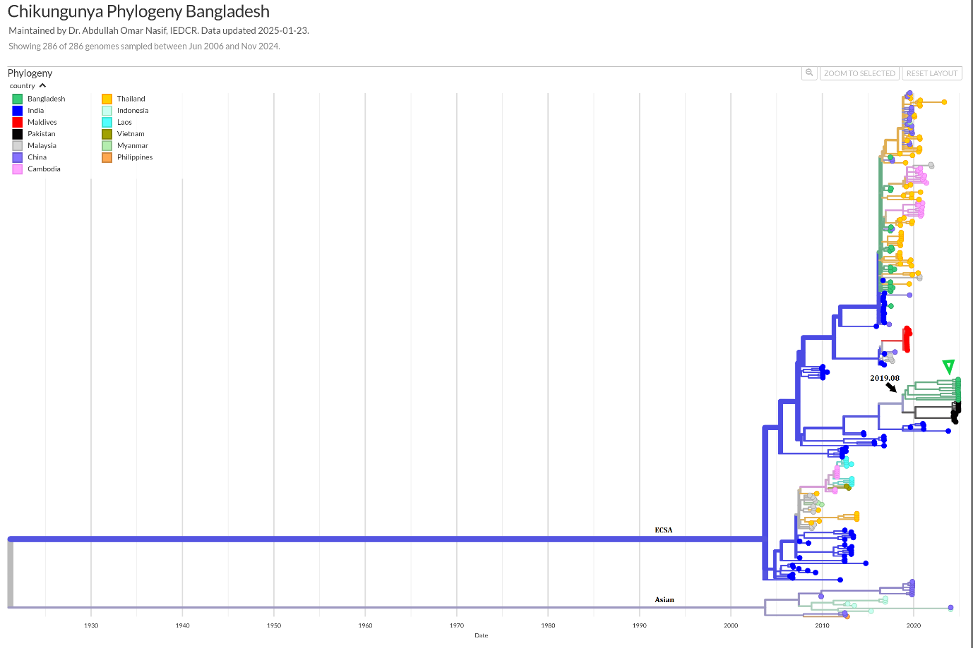

**Figure 3:** Time-scaled phylogeny of Chikungunya viruses circulating in Asia showing 286 genomes sampled between June 2006 and November 2024. The colour of the tips indicated the host country of the taxa. Branch colour indicated the inferred ancestral geographic location of the descendants.Genotype was indicated adjacent to the key branches. The number above the black arrow denoted the inferred year of introduction of the currently circulating lineage in Bangladesh. The green triangle indicates the sequenced samples in this study. Numbers in the X axis represent the time in the unit of year.

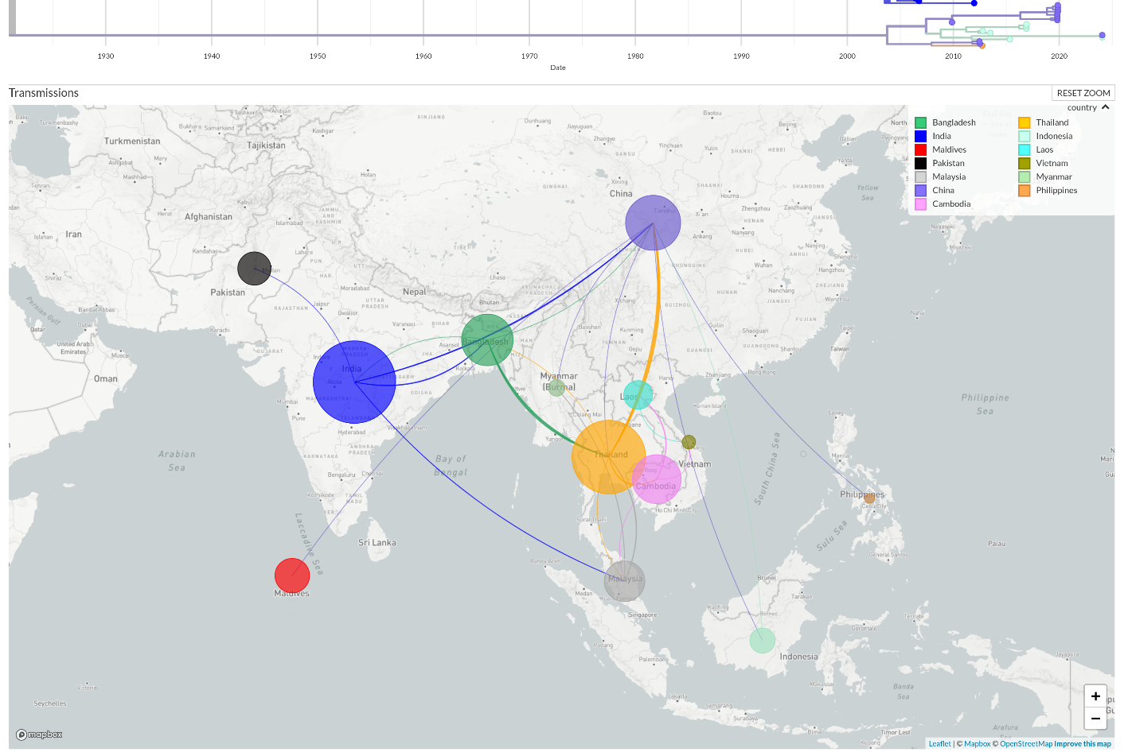

**Figure 4:** Geographical transmission map of Chikungunya viruses in Asia showing the regional movement of viruses. The placement of the circles (demes) in the map is according to the sampling location. The size of the demes indicates the number of sequences sampled from a specific country. Colours of the demes are according to the Countries indicated in the legend. The shape & colour of the transmission lines denotes the direction of the virus movement.

**Discussion:**

The re-emergence of the CHIKV in Dhaka, Bangladesh, came after a near disappearance of the virus following the 2017 outbreak highlighting a serious concern, especially in the context of the ongoing and large-scale dengue epidemic in Bangladesh, which continues to place significant strain on public health systems [24,25]. The clinical characteristics observed in this study are consistent with prior reports of CHIKV infections, with fever, arthralgia, myalgia, and headache being the predominant symptoms [1]. Importantly, more than half of the patients who were followed up reported persistent symptoms at 28 days follow-up, underscoring the potential long-term health impact of CHIKV infections, even in the absence of fatalities.

The study also provides valuable insights into disease severity, which was found to be higher in individuals aged over 30 years and those presenting with more severe clinical signs. The need for hospitalization among 14.5% of patients and the loss of working days further emphasize the social and economic burden associated with the outbreak. This is particularly concerning given the fact that the healthcare systems are already overburdened due to the ongoing dengue crisis.

The phylogenetic analysis revealed the evolution and emergence of a new sub-lineage within the previously circulating ECSA genotype of the virus in Bangladesh. These outbreak strains are closely related and their most recent common ancestor likely evolved during early 2019, from the previously circulating local strains rather than being introduced from external sources. Notably, the sequences in this study lack the E1-A226V substitution but carry the E1-K211E. Chikungunya viruses sequenced during the 2017 outbreak in Bangladesh were also found to harbour this substitution [26]. Previous studies have shown that the E1-K211E substitution enhances the virus's fitness in *Aedes aegypti* mosquitoes [27]. Given the abundance of this mosquito species in urban areas of Bangladesh, this finding raises serious concerns about the potential for large-scale outbreaks in major cities across the country.

Bangladesh provides a highly conducive and favourable environment for *Aedes* mosquito breeding, including factors such as rapid urbanization, extended rainfall, and numerous mosquito breeding sites [28]. Additionally, the temperature in the country remains highly favourable for Aedes mosquitoes for approximately nine out of the 12 months each year [28]. The recent dengue outbreak has also demonstrated that rural areas are equally affected, suggesting that *Aedes albopictus* mosquitoes may be adapting to these regions [29]. Furthermore, with a high basic reproduction number (*R0*) for Chikungunya virus—estimated at 3.4 globally [30] and 4.2 during the 2017 outbreak in Bangladesh [9] —it is likely that CHIKV will cause a large outbreak in the near future e.g. 2025 or 2026. In 2023, Bangladesh experienced the largest dengue outbreak in its history, leading to a national crisis involving shortages of intravenous saline solutions and hospital beds [24]. This article serves as a crucial alert to prepare for a potential large-scale outbreak of CHIKV in near future.

**Acknowledgement:**

We are grateful to WHO Bangladesh country office for providing Real-time PCR reagents for detection of Chikungunya virus. We acknowledge the patients for providing the samples and data for this study. We also gratefully acknowledge all data contributors, i.e., the Authors and their Originating laboratories responsible for obtaining the specimens, and their Submitting laboratories for generating the genetic sequence and metadata and sharing via the GISAID Initiative, on which the phylogenetic analysis is based.

**Financial Support**

There was no funding for this study.

**Conflicts of interest**

The authors declare no conflict of interest.

**Ethics statement**

This study is a part of the response to chikungunya outbreaks in Bangladesh, 2024 and thus exempted from the formal ethical application. There are no identifiable individual-level data, and ethical approval is not required.

**Author Contributions**

Conceptualization: AON, and NH. Data curation: AON, MNH. Formal Analysis: AON, MNH, NH. Writing original draft: NH & AON. Supervision: TS and ANA. Writing, review, and editing: IM, OQ, MRH, MHK, SS, JF, KTPP, MR, MR, ANA, TS.

**References**

1. Vairo F, Haider N, Kock R, Ntoumi F, Ippolito G, Zumla A. Chikungunya: Epidemiology, Pathogenesis, Clinical Features, Management, and Prevention. Vol. 33, Infectious Disease Clinics of North America. W.B. Saunders; 2019. p. 1003–25.

2. Robinson MC. An epidemic of virus disease in Southern Province, Tanganyika territory, in 1952–1953. Trans R Soc Trop Med Hyg. 1955;49:28–32.

3. Robinson M, Conan A, Duong V, Ly S, Ngan C, Buchy P, Tarantola A, Rodó X. A Model for a Chikungunya Outbreak in a Rural Cambodian Setting: Implications for Disease Control in Uninfected Areas. PLoS Negl Trop Dis. 2014;8(9):12–4.

4. Yakob L, Clements ACA. A Mathematical Model of Chikungunya Dynamics and Control: The Major Epidemic on Réunion Island. PLoS One. 2013;8(3):1–6.

5. Nsoesie EO, Kraemer MU, Golding N, Pigott DM, Brady OJ, Moyes CL, Johansson MA, Gething PW, Velayudhan R, Khan K, Hay SI, Brownstein JS. Global distribution and environmental suitability for chikungunya virus, 1952 to 2015. Eurosurveillance. 2016 May 19;21(20).

6. Khatun S, Chakraborty A, Rahman M, Nasreen Banu N, Rahman MM, Hasan SMM, Luby SP, Gurley ES. An Outbreak of Chikungunya in Rural Bangladesh, 2011. PLoS Negl Trop Dis. 2015 Jul 10;9(7):e0003907.

7. Haque F, Rahman M, Banu NN, Sharif AR, Jubayer S, Shamsuzzaman A, Alamgir A, Erasmus JH, Guzman H, Forrester N, Luby SP, Gurley ES. An epidemic of chikungunya in northwestern Bangladesh in 2011. PLoS One. 2019 Mar 11;14(3):e0212218.

8. Kabir I, Dhimal M, Müller R, Banik S, Haque U. The 2017 Dhaka chikungunya outbreak. Lancet Infect Dis. 2017 Nov;17(11):1118.

9. Mahmud AS, Kabir MdI, Engø-Monsen K, Tahmina S, Riaz BK, Hossain MdA, Khanom F, Rahman MdM, Rahman MdK, Sharmin M, Hossain DM, Yasmin S, Ahmed MdM, Lusha MAF, Buckee CO. Megacities as drivers of national outbreaks: The 2017 chikungunya outbreak in Dhaka, Bangladesh. PLoS Negl Trop Dis. 2021 Feb 2;15(2):e0009106.

10. Allen SW, Ribeiro Dos Santos G, Paul KK, Paul R, Rahman MZ, Alam MS, Rahman M, Al-Amin HM, Vanhomwegen J, Weaver SC, Smull T, Lee KH, Gurley ES, Salje H. Results of a Nationally Representative Seroprevalence Survey of Chikungunya Virus in Bangladesh. J Infect Dis. 2024 Nov 15;230(5):e1031–8.

11. Sam IC, Loong SK, Michael JC, Chua CL, Wan Sulaiman WY, Vythilingam I, Chan SY, Chiam CW, Yeong YS, AbuBakar S, Chan YF. Genotypic and Phenotypic Characterization of Chikungunya Virus of Different Genotypes from Malaysia. PLoS One [Internet]. 2012 Nov 27 [cited 2025 Feb 18];7(11):e50476. Available from: https://journals.plos.org/plosone/article?id=10.1371/journal.pone.0050476

12. De Coster W, Rademakers R. NanoPack2: population-scale evaluation of long-read sequencing data. Bioinformatics [Internet]. 2023 May 4 [cited 2024 Apr 5];39(5). Available from: https://dx.doi.org/10.1093/bioinformatics/btad311

13. Li H. Minimap2: pairwise alignment for nucleotide sequences. Bioinformatics [Internet]. 2018 Sep 15 [cited 2025 Feb 18];34(18):3094–100. Available from: https://dx.doi.org/10.1093/bioinformatics/bty191

14. Danecek P, Bonfield JK, Liddle J, Marshall J, Ohan V, Pollard MO, Whitwham A, Keane T, McCarthy SA, Davies RM. Twelve years of SAMtools and BCFtools. Gigascience [Internet]. 2021 Jan 29 [cited 2024 Feb 19];10(2):1–4. Available from: https://dx.doi.org/10.1093/gigascience/giab008

15. nanoporetech/medaka: Sequence correction provided by ONT Research [Internet]. [cited 2024 Feb 19]. Available from: https://github.com/nanoporetech/medaka?tab=readme-ov-file

16. Wallau GL, Abanda NN, Abbud A, Abdella S, Abera A, Ahuka-Mundeke S, Falconi-Agapito F, Alagarasu K, Ariën KK, Ayres CFJ, Barzon L, Bonney JHK, Boumbaly S, Buchy P, Cao-Lormeau VM, Chem YK, Cardenas PA, Castillo AE, Delfraro A, Devine G, Duong V, Dupont-Rouzeyrol M, Fadeev A V., Fajardo A, Diaz LA, Gómez LF, Gudo ES, Gutierrez-Bugallo G, Hapuarachchi HC, Heraud JM, Hibberd ML, Inlamea OF, Jasmin N, Kydyshov K, Kelly ME, Khan S, Komissarov AB, Leaungwutiwong P, Leguia M, Lustig Y, Maciel-de-Freitas R, Malavige GN, Martinez AA, Mendoza ML, Mo LT, Moreno B, Mwasi L, Naveca FG, NG LC, Njouom R, Nogueira ML, Ntoumi F, Nzoyikorera N, Parra BA, Pichardo MV, Privaldos KJR, Rivero R, Rojas AM, Salvato RS, Sasmono RT, Schmidt-Chanasit J, Simon-Loriere E, Sy AKD, Talledo-Albujar M, Tizhe DT, Toloshovich UN, Tran VT, Troupin C, Kayiwa JT, van den Hurk A, Vasilakis N, Weldemariam AG, Yacoub S, Zaini Z. Arbovirus researchers unite: expanding genomic surveillance for an urgent global need. Lancet Glob Health [Internet]. 2023 Oct 1 [cited 2025 Feb 18];11(10):e1501–2. Available from: http://www.thelancet.com/article/S2214109X2300325X/fulltext

17. Chikungunya Virus Typing Tool [Internet]. [cited 2025 Feb 18]. Available from: https://www.genomedetective.com/app/typingtool/chikungunya/

18. Hadfield J, Megill C, Bell SM, Huddleston J, Potter B, Callender C, Sagulenko P, Bedford T, Neher RA. Nextstrain: real-time tracking of pathogen evolution. Bioinformatics [Internet]. 2018 Dec 1 [cited 2024 Feb 19];34(23):4121–3. Available from: https://dx.doi.org/10.1093/bioinformatics/bty407

19. Nguyen LT, Schmidt HA, Von Haeseler A, Minh BQ. IQ-TREE: A Fast and Effective Stochastic Algorithm for Estimating Maximum-Likelihood Phylogenies. Mol Biol Evol [Internet]. 2015 Jan 1 [cited 2025 Feb 18];32(1):268–74. Available from: https://dx.doi.org/10.1093/molbev/msu300

20. Katoh K, Misawa K, Kuma KI, Miyata T. MAFFT: a novel method for rapid multiple sequence alignment based on fast Fourier transform. Nucleic Acids Res [Internet]. 2002 Jul 15 [cited 2025 Feb 18];30(14):3059–66. Available from: https://dx.doi.org/10.1093/nar/gkf436

21. Sagulenko P, Puller V, Neher RA. TreeTime: Maximum-likelihood phylodynamic analysis. Virus Evol [Internet]. 2018 Jan 1 [cited 2025 Feb 18];4(1). Available from: https://dx.doi.org/10.1093/ve/vex042

22. R Core Team. R: A Language and Environment for Statistical Computing. Austria; 2020.

23. World Bank. GDP per capita (current US$). New Tork; 2023 Jan.

24. Haider N, Asaduzzaman M, Hassan MN, Rahman M, Sharif AR, Ashrafi SAA, Lee SS, Zumla A. Bangladesh’s 2023 Dengue outbreak – age/gender-related disparity in morbidity and mortality and geographic variability of epidemic burdens. International Journal of Infectious Diseases. 2023 Sep;

25. Hasan MN, Rahman M, Uddin M, Ashrafi SAA, Rahman KM, Paul KK, Sarker MFR, Haque F, Sharma A, Papakonstantinou D, Paudyal P, Asaduzzaman M, Zumla A, Haider N. The 2023 fatal dengue outbreak in Bangladesh highlights a paradigm shift of geographical distribution of cases. Epidemiol Infect. 2025 Jan 7;153:e3.

26. Melan A, Aung MS, Khanam F, Paul SK, Riaz BK, Tahmina S, Kabir MI, Hossain MA, Kobayashi N. Molecular characterization of chikungunya virus causing the 2017 outbreak in Dhaka, Bangladesh. New Microbes New Infect. 2018 Jul 1;24:14–6.

27. Berry IM, Eyase F, Pollett S, Konongoi SL, Joyce MG, Figueroa K, Ofula V, Koka H, Koskei E, Nyunja A, Mancuso JD, Jarman RG, Sang R. Global Outbreaks and Origins of a Chikungunya Virus Variant Carrying Mutations Which May Increase Fitness for Aedes aegypti: Revelations from the 2016 Mandera, Kenya Outbreak. Am J Trop Med Hyg [Internet]. 2019 Mar 11 [cited 2025 Feb 18];100(5):1249–57. Available from: https://www.ajtmh.org/view/journals/tpmd/100/5/article-p1249.xml

28. Hasan MN, Khalil I, Chowdhury MAB, Rahman M, Asaduzzaman M, Billah M, Banu LA, Alam MU, Ahsan A, Traore T, Uddin MJ, Galizi R, Russo I, Zumla A, Haider N. Two decades of endemic dengue in Bangladesh (2000–2022): trends, seasonality, and impact of temperature and rainfall patterns on transmission dynamics. J Med Entomol. 2024 Jan 22;

29. Rahman MdS, Faruk MdO, Tanjila S, Sabbir NM, Haider N, Chowdhury S. Entomological survey for identification of Aedes larval breeding sites and their distribution in Chattogram, Bangladesh. Beni Suef Univ J Basic Appl Sci. 2021;10(1).

30. Haider N, Vairo F, Ippolito G, Zumla A, Kock RA. Basic Reproduction Number of Chikungunya Virus Transmitted by Aedes Mosquitoes. Emerg Infect Dis [Internet]. 2020 Oct 1;26(10):2429–31. Available from: https://www.biorxiv.org/content/10.1101/122556v1.

**Table 2:** Sequencing findings and related metadata of 12 Chikungunya Viruses from 2024 Outbreak

|  |  |  |  |  |  |  |  |  |  |  |  |
| --- | --- | --- | --- | --- | --- | --- | --- | --- | --- | --- | --- |
| **Serial** | **Sequence ID** | **Collection Date (YYYY-MM-DD)** | **Geographical Location** | **Sex** | **Age (years)** | **Patient status during Sample collection** | **Accession (GISAID/**  **GenBank)** | **Sequence Length** | **Sequencing Depth (×)** | **Genotype** | **Mutations** |
| 1 | **OIS23-288** | 2024-11-07 | Dhaka | F | 49 | Live | EPI_ISL_19683650/ [PQ963011](https://www.ncbi.nlm.nih.gov/nuccore/PQ963011) | 1510 | 987 | ECSA | D284E, I55V, K211E, M269V, V322A |
| 2 | **OIS23-299** | 2024-11-10 | Dhaka | M | 48 | Live | EPI_ISL_19683651/ [PQ963012](https://www.ncbi.nlm.nih.gov/nuccore/PQ963012) | 1510 | 1147 | ECSA | D284E, I55V, K211E, M269V |
| 3 | **OIS23-306** | 2024-11-12 | Dhaka | F | 32 | Live | EPI_ISL_19683652/ [PQ963013](https://www.ncbi.nlm.nih.gov/nuccore/PQ963013) | 1510 | 771 | ECSA | D284E, I55V, K211E, M269V |
| 4 | **OIS23-309** | 2024-11-12 | Dhaka | M | 32 | Live | EPI_ISL_19683653/ [PQ963014](https://www.ncbi.nlm.nih.gov/nuccore/PQ963014) | 1510 | 413 | ECSA | D284E, I55V, K211E, M269V, V322A |
| 5 | **OIS23-313** | 2024-11-13 | Dhaka | M | 60 | Live | EPI_ISL_19683654/ [PQ963015](https://www.ncbi.nlm.nih.gov/nuccore/PQ963015) | 1510 | 853 | ECSA | D284E, I55V, K211E, M269V, V322A |
| 6 | OIS23-347 | 2024-11-17 | Dhaka | F | 35 | Hospitalized | EPI_ISL_19683655/ [PQ963016](https://www.ncbi.nlm.nih.gov/nuccore/PQ963016) | 1510 | 1250 | ECSA | D284E, I55V, K211E, M269V, V322A |
| 7 | OIS23-351 | 2024-11-18 | Dhaka | F | 37 | Live | EPI_ISL_19683656/ [PQ963017](https://www.ncbi.nlm.nih.gov/nuccore/PQ963017) | 1510 | 975 | ECSA | D284E, I55V, K211E, M269V, V322A |
| 8 | OIS23-352 | 2024-11-18 | Dhaka | M | 30 | Live | EPI_ISL_19683657/ [PQ963018](https://www.ncbi.nlm.nih.gov/nuccore/PQ963018) | 1510 | 1021 | ECSA | D284E, I55V, K211E, M269V |
| 9 | OIS23-365 | 2024-11-19 | Dhaka | F | 31 | Live | EPI_ISL_19683658/ [PQ963019](https://www.ncbi.nlm.nih.gov/nuccore/PQ963019) | 1510 | 490 | ECSA | D284E, I55V, K211E, M269V, V322A |
| 10 | OIS23-373 | 2024-11-20 | Dhaka | M | 56 | Live | EPI_ISL_19683659/ [PQ963020](https://www.ncbi.nlm.nih.gov/nuccore/PQ963020) | 1510 | 499 | ECSA | D284E, I55V, K211E, M269V |
| 11 | OIS23-384 | 2024-11-21 | Dhaka | F | 48 | Live | EPI_ISL_19683660/ [PQ963021](https://www.ncbi.nlm.nih.gov/nuccore/PQ963021) | 1510 | 857 | ECSA | D284E, I55V, K211E, M269V, V367A |
| 12 | OIS23-403 | 2024-11-25 | Dhaka | M | 35 | Hospitalized | EPI_ISL_19683661/ [PQ963022](https://www.ncbi.nlm.nih.gov/nuccore/PQ963022) | 1510 | 709 | ECSA | D284E, I55V, K211E, M269V, V322A |